

台州学院
《Java高级程序设计》
实验报告

实验项目: 实验4 会话技术应用
学号姓名: 2X计奇2X00000000无名氏
专 业：计算机科学与技术
班 级：21计应1班
实验时间：第10-11次课 三/四/五

电子与信息工程学院

一、实验目的及要求：
1)熟练使用cookie;
2)熟练使用session。
3)应用session,实现注册和登录; 其中注意使用Seeion验证。
二、实验内容：
1. 写一个FindSaveCookieServlet：先查询是否有一个名叫username的cookie，如果有，则显示该cookie的值；如果没有，则创建该Cookie cookie = new Cookie("username","zs")。
2.写一个count.jsp，实现客户端访问该count.jsp时，在客户端显示该客户端是当前这一次会话中是第几次访问该应用项目。
3. 设计与实现登录与注册模块。要求：1) 注册：使用session和js，进行验证码验证。若用户名已经存在，则提示用户。注册成功，自动跳转到登录页面。2）登录：比较用户名与密码，若不匹配，则给用户相应提示。若匹配成功，则自动跳转到主功能页面(main.jsp)。3)使用session验证，控制使得仅当登录成功之后才能进入到main.jsp页面。没有登录与登录不成功均不能进入到main.jsp页面。

三、实验代码及运行结果（包括可能有的截图）：
1.
package servlet;

import javax.servlet.*;
import javax.servlet.http.*;
import javax.servlet.annotation.*;
import java.io.IOException;
import java.io.PrintWriter;
import java.net.URLDecoder;

@WebServlet("/find")
public class FindCookie extends HttpServlet {
@Override
protected void service(HttpServletRequest request, HttpServletResponse response) throws ServletException, IOException {
Cookie[] cookies=request.getCookies();
response.setContentType("text/html;charset=utf-8");
PrintWriter out=response.getWriter();
if(cookies!=null){
for(int i=0;i<cookies.length;++i){
Cookie curr=cookies[i];
String name= curr.getName();
String value=curr.getValue();
value= URLDecoder.decode(value,"utf-8");
out.println("<h1>"+name+" "+value+"</h1>");
}
}
out.close();
}

}
package servlet;

import javax.servlet.*;
import javax.servlet.http.*;
import javax.servlet.annotation.*;
import java.io.IOException;
import java.io.PrintWriter;
import java.net.URLEncoder;

@WebServlet("/save")
public class SaveCookie extends HttpServlet {
public void service(HttpServletRequest request,HttpServletResponse response)
throws ServletException,IOException{
String name= URLEncoder.encode("张三","utf-8");
Cookie cookie =new Cookie("username",name);
Cookie cookie2=new Cookie("password","test");
cookie2.setMaxAge(100);
response.addCookie(cookie);
response.addCookie(cookie2);
response.setContentType("text/html");
PrintWriter out=response.getWriter();
out.println("<h1>add cookie success</h1>");
out.close();
}
}
Find and Save
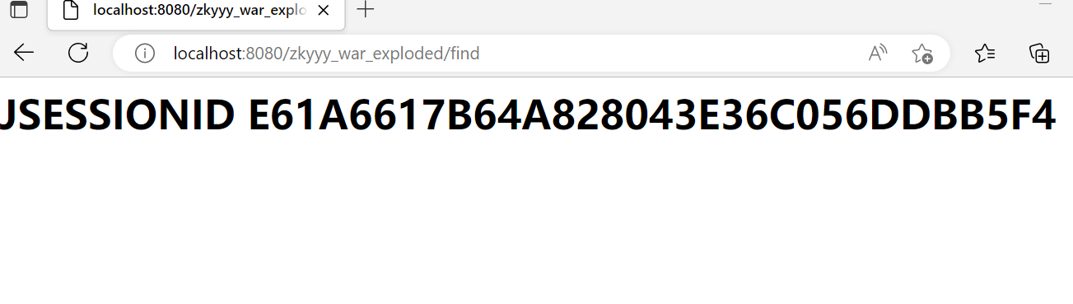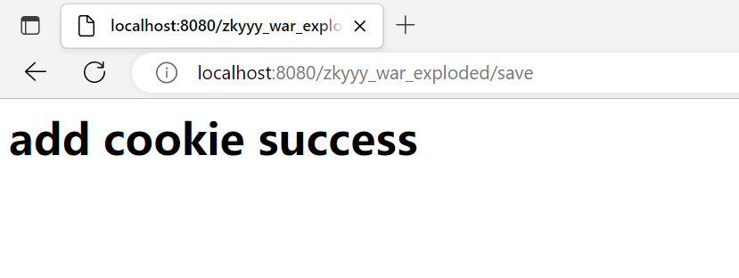

2.
package servlet;

import javax.servlet.*;
import javax.servlet.http.*;
import javax.servlet.annotation.*;
import java.io.IOException;
import java.io.PrintWriter;

@WebServlet("/count")
public class

CountServlet extends HttpServlet {
@Override
protected void service(HttpServletRequest request, HttpServletResponse response) throws ServletException, IOException {
HttpSession session=request.getSession();
System.out.println("sessionId:"+session.getId());
session.setMaxInactiveInterval(30);

Integer count=(Integer) session.getAttribute("count");

if(count==null){
count=1;
}else{
count++;
}
session.setAttribute("count",count);
response.setContentType("text/html");
PrintWriter out=response.getWriter();
out.println("<h1>you have visit: "+count+"</h1>");
out.close();
}
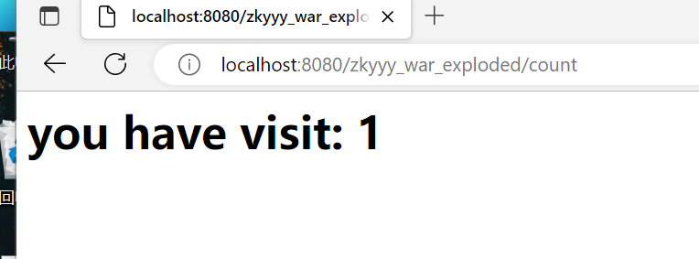
}

3.
EmployeeDAO
package dao;
import util.DBUtil_d;
import entity.Employee;
import java.sql.*;
public class EmployeeDAO {
public boolean check(String username)throws Exception{
Connection conn= DBUtil_d.getConnection();
PreparedStatement prep=conn.prepareStatement("select * from t_user where username=?");
prep.setString(1,username);
ResultSet res= prep.executeQuery();
Employee employee=null;
while(res.next()){
employee=new Employee();
employee.setID(res.getLong("id"));
employee.setUsername(res.getString("username"));
employee.setName(res.getString("name"));
employee.setPassword(res.getString("password"));
employee.setSex(res.getString("sex"));
}
DBUtil_d.close(conn);
if(employee==null)
return true;
else
return false;
}
public void add(String username,String name,String password,String sex)throws Exception{
Connection conn= DBUtil_d.getConnection();
PreparedStatement prep = conn.prepareStatement("insert into t_user(username,name,password,sex) values(?,?,?,?)");
prep.setString(1,username);
prep.setString(2,name);
prep.setString(3,password);
prep.setString(4,sex);
prep.executeUpdate();
DBUtil_d.close(conn);
}
public Employee find(String username) throws Exception{
Employee user = null;
Connection conn = DBUtil_d.getConnection();
PreparedStatement prep =
conn.prepareStatement("select * from t_user where username=?");
prep.setString(1, username);
ResultSet rst = prep.executeQuery();
if (rst.next()) {
user = new Employee();
user.setID(rst.getLong("id"));
user.setUsername(username);
user.setName(rst.getString("name"));
user.setSex(rst.getString("sex"));
user.setPassword(rst.getString("password"));
}
DBUtil_d.close(conn);
return user;
}
}
Employee
package entity;

public class Employee {
private String username;
private String name;
private String password;
private String sex;
private long id;
public Employee(String username,String name, String password,String sex){
super();
this.username=username;
this.password=password;
this.sex=sex;
this.name=name;
}
public Employee(){
}
public String getUsername(){ return username; }
public void setUsername(String username){ this.username= username; }
public String getPassword(){ return password; }
public void setPassword(String password){ this.password= password; }
public String getName(){ return name; }
public void setName(String name){ this.name= name; }
public String getSex(){return sex;}
public void setSex(String sex){this.sex=sex;}
public long getId(){ return id; }
public void setID(long id){ this.id= id; }
}
checkcode
package servlet;

import com.sun.image.codec.jpeg.JPEGCodec;
import com.sun.image.codec.jpeg.JPEGImageEncoder;

import javax.servlet.*;
import javax.servlet.http.*;
import javax.servlet.annotation.*;
import java.awt.*;
import java.awt.image.BufferedImage;
import java.io.IOException;
import java.io.OutputStream;
import java.util.Random;

@WebServlet("/checkcode")
public class CheckCode extends HttpServlet {
protected void service(HttpServletRequest request, HttpServletResponse response) throws ServletException, IOException {
response.setContentType("image/jpeg");
BufferedImage image=new BufferedImage(60,20,BufferedImage.TYPE_INT_BGR);
Graphics g=image.getGraphics();
Random r= new Random();
g.setColor(new Color(r.nextInt(255),r.nextInt(255),r.nextInt(255)));
g.fillRect(0,0,60,20);
g.setColor(new Color(0,0,0));
String number=String.valueOf(r.nextInt(99999));
HttpSession session=request.getSession();
session.setAttribute("number",number);
g.drawString(number,5,15);
g.setColor(new Color(r.nextInt(255),r.nextInt(255),r.nextInt(255)));
g.drawLine(r.nextInt(60),r.nextInt(20),r.nextInt(60),r.nextInt(20));
OutputStream os=response.getOutputStream();
JPEGImageEncoder encoder= JPEGCodec.createJPEGEncoder(os);
encoder.encode(image);
}
}
MgmtEmp2
package servlet;

import dao.EmployeeDAO;
import entity.Employee;

import javax.servlet.*;
import javax.servlet.http.*;
import javax.servlet.annotation.*;
import java.io.IOException;

@WebServlet("/do")
public class MgmtEmp2 extends HttpServlet {
protected void service(HttpServletRequest request, HttpServletResponse response) throws ServletException, IOException {
String path=request.getParameter("path");
if(path.equals("/regist")) {
HttpSession session=request.getSession();
String number2=(String)session.getAttribute("number");
String number1=request.getParameter("number");
if(number1.equals(number2)){//验证码一样，接下来验证用户名有没有重
String username=request.getParameter("username");
String name=request.getParameter("name");
String password=request.getParameter("pwd");
String sex=request.getParameter("sex");
EmployeeDAO dao=new EmployeeDAO();
try {
boolean f = dao.check(username);
if(f==true){
dao.add(username,name,password,sex);
request.getRequestDispatcher("login.jsp").forward(request, response);
}else{
request.setAttribute( "regist_err","this name already exists!");
request.getRequestDispatcher("regist.jsp").forward(request, response);
}
} catch (Exception e) {
e.printStackTrace();
}
}else{
request.setAttribute( "checkcode_err","验证码错误");
request.getRequestDispatcher("regist.jsp").forward(request, response);
}
}else if(path.equals("/login")){
String username = request.getParameter("username");
String pwd = request.getParameter("pwd");
EmployeeDAO Dao = new EmployeeDAO();
try {
Employee user = Dao.find(username);
if (user != null && pwd.equals(user.getPassword())) {
HttpSession session = request.getSession();
session.setAttribute("username",username);
response.sendRedirect("main.jsp");
}else {
request.setAttribute("login_err", "用户名或密码错误");
request.getRequestDispatcher("login.jsp").forward(request, response);
}
} catch (Exception e) {
e.printStackTrace();
}
}
}
}
DBUtil_d
package util;

import java.sql.Connection;
import java.sql.DriverManager;
import java.sql.SQLException;

public class DBUtil_d {
public static Connection getConnection(){
Connection conn=null;
try{
Class.forName("com.mysql.jdbc.Driver");
conn = DriverManager.getConnection("jdbc:mysql://localhost:3306/db5?useUnicode=true&characterEncoding=utf-8",
"root","123456");
} catch (ClassNotFoundException e) {
e.printStackTrace();
}catch (SQLException e){
e.printStackTrace();
}
return conn;
}
public static void close(Connection conn){
if(conn!=null) {
try{
conn.close();
} catch (SQLException e) {
e.printStackTrace();
}
}
}
}
Login.jsp
<%@page pageEncoding="utf-8" contentType="text/html;charset=utf-8"%>
<html>
<head></head>
<body>
<form action="do?path=/login" method="post">
<fieldset>
<legend>
登录<br>
</legend>
你的昵称是:
<input type="text" name="username">
<br />
你的密码是:
<input type="password" name="pwd">
<br />
<%
String info = (String) request.getAttribute("login_err");
%>
<span><%=(info == null ? "" : info)%></span>
<br />
<input type="submit" value="confirm">
</fieldset>
</form>
</body>
</html>
Mian.jsp

<%--
Created by IntelliJ IDEA.
User: 23705
Date: 2022/11/27
Time: 15:16
To change this template use File | Settings | File Templates.
--%>
<%@ page contentType="text/html;charset=UTF-8" language="java" %>
<html>
<head>
<title>Title</title>
</head>
<body>
登录成功
</body>
</html>

Regist.jsp
<%@page pageEncoding="utf-8" contentType="text/html; charset=utf-8"%>
<html>
<head></head>
<title>Title</title>
<body style="">
<form action="do?path=/regist" method="post">
<fieldset>
<legend>
注册
</legend>
用户名：
<input type="text" name="username"/>
<%
String info=(String) request.getAttribute("regist_err");
%>
<span style="">
<%=(info == null ?"":info)%>
</span>
<br/>
真实姓名：
<input type="text" name="name"/>
<br/>
密码：
<input type="password" name="pwd"/>
<br/>
性别:男
<input type="radio" name="sex" value="m" checked="checked"/>
女
<input type="radio" name="sex" value="f"/>
<br/>
验证码：
<img src="checkcode" id="img1" />
<a href="javascript:;"
onclick="document.getElementById('img1').src='checkcode?'+Math.random();">换一个</a>
<input type="text" name="number"/>
<%
String info2=(String) request.getAttribute("checkcode_err");
%>
<span style=""><%=(info2 == null ? "" : info2)%></span>
<br/>
<input type="submit" value="确认" onclick="location='do?path=/regist'">
</fieldset>
</form>
</body>
</html>

注册
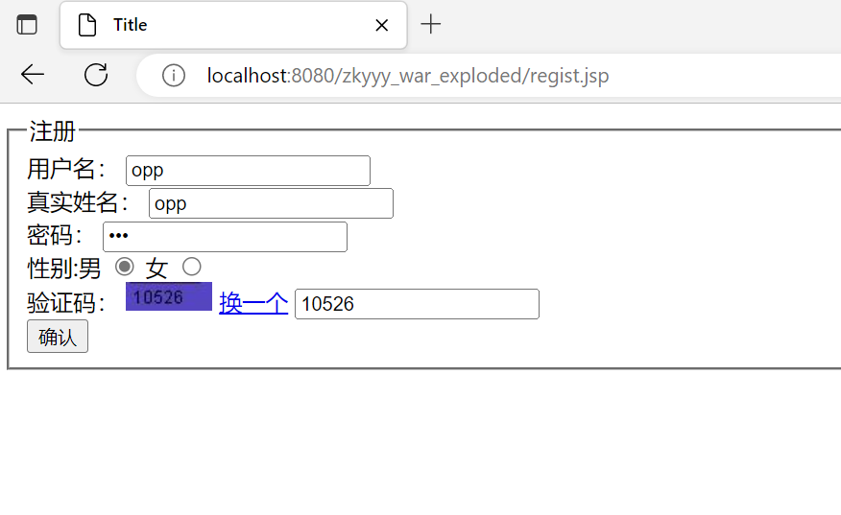

注册成功后登录
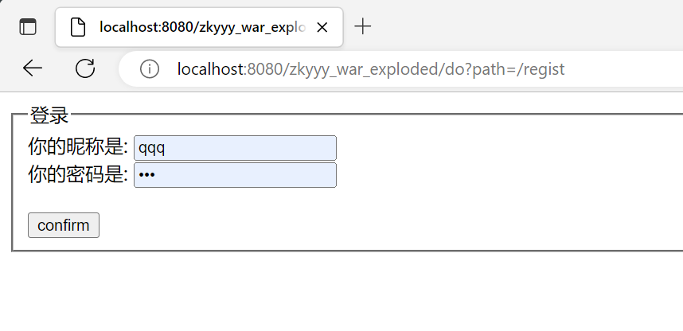

登录成功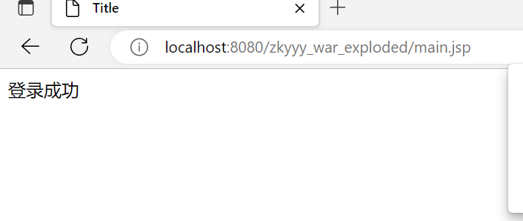

用户名重复
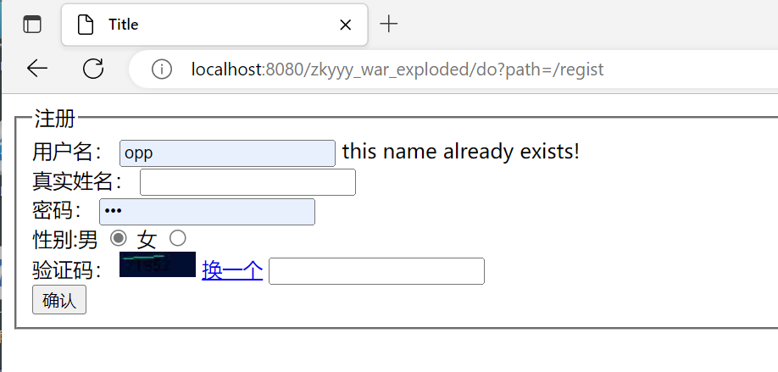

验证码错误
